Log in to the RBJSL website
www.RBJSL.org

VIEWING SCHEDULES

Click on Schedules and Standings in the upper left hand corner

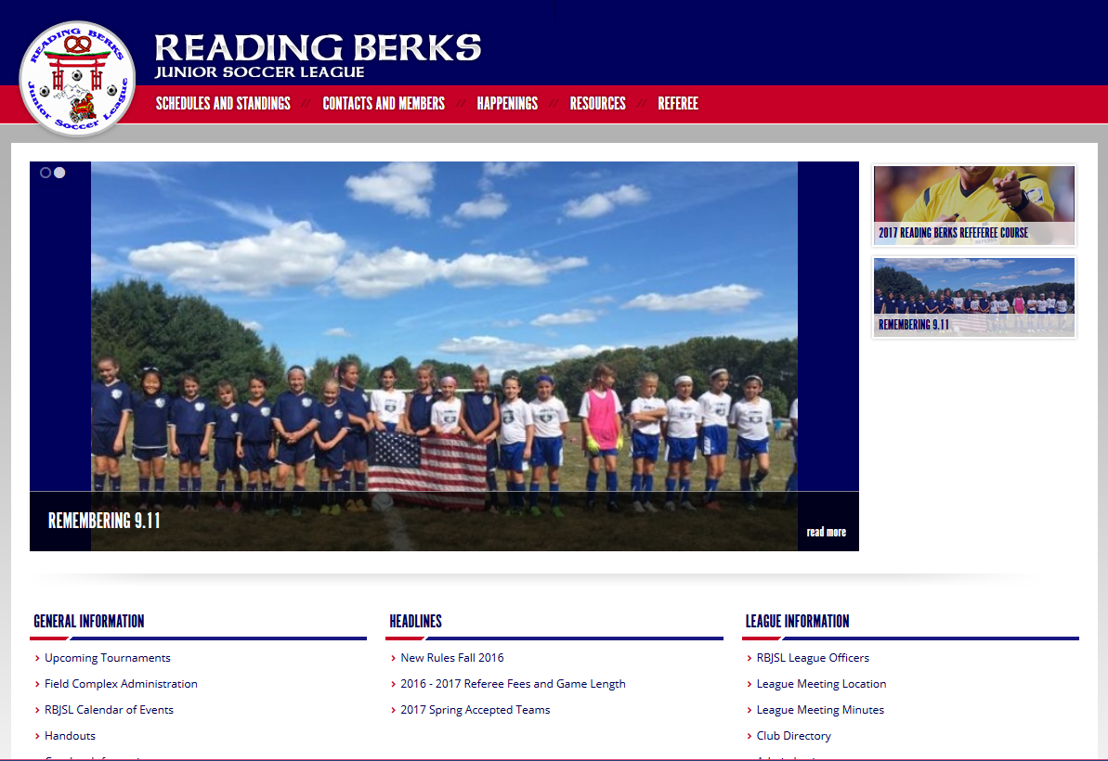

Select the Schedule and Scroll through and select the division you are interested in.

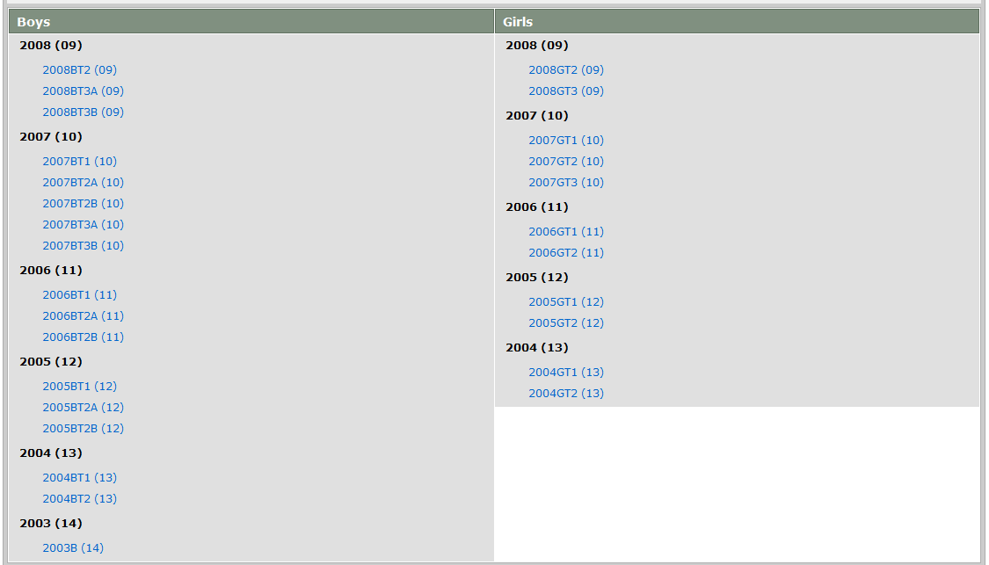

It will show the division schedule

Click on your team name.

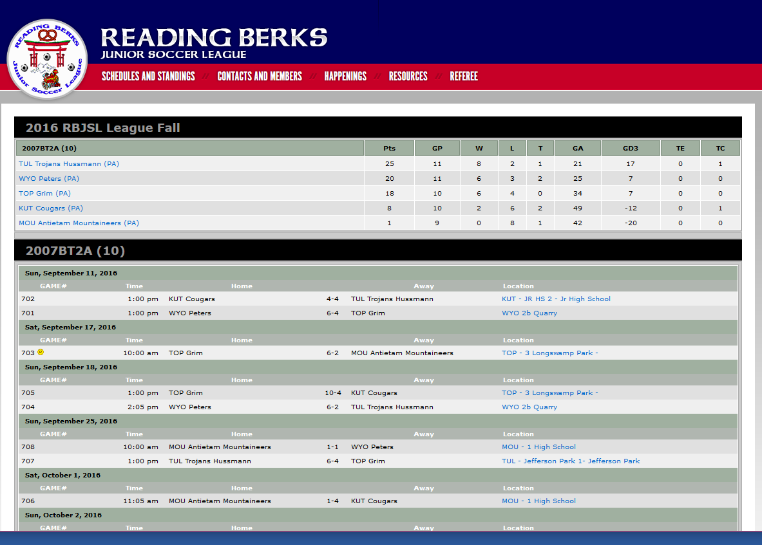

Next it will show the schedule just for your team.

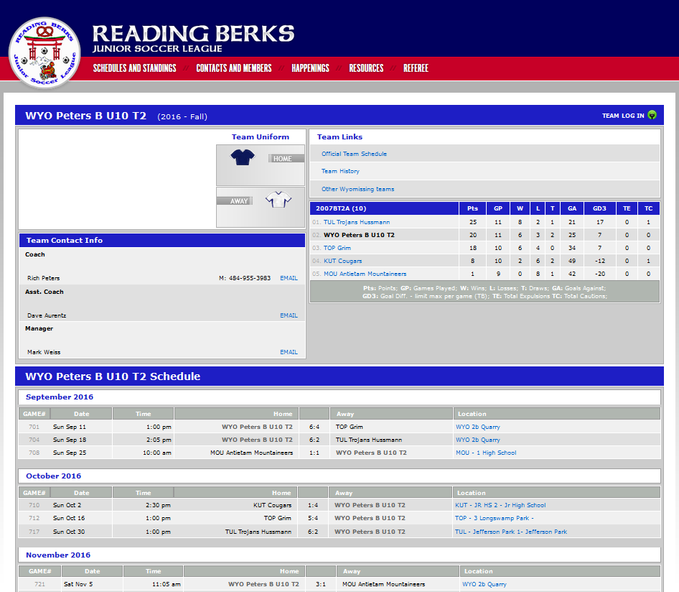

SCORE REPORTING

Follow the steps from above.

In the upper right corner it will say Team Log In

Click on this link

You will be asked to enter your email address and PIN#

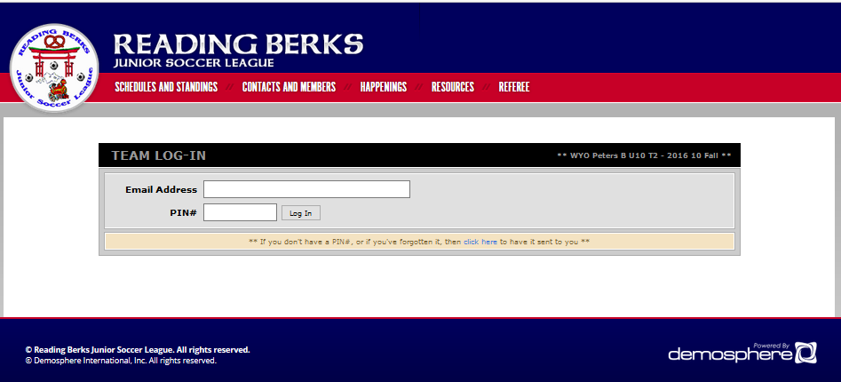

Click on Log In

The next panel will ask where do you want to start?

Select on Team Score Reporting.

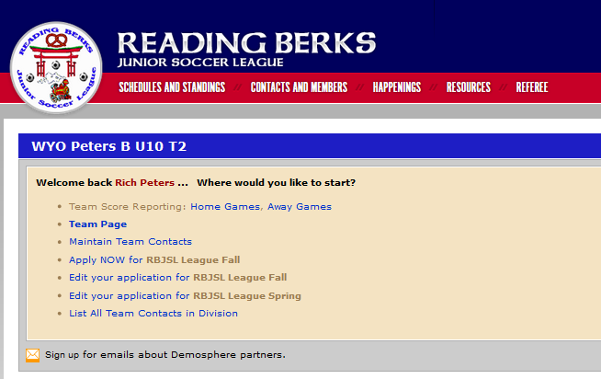

This will take you to the schedule and allow you to enter the scores after the date when you were scheduled to play. If the score is already entered, confirm the score is correct and Log Out.

CONTACT INFORMATION

To change team contact information, follow the same steps from above. When you get to the team page you can click on Team Page and then click on Contacts

Select the GREEN + sign next to the person you want to modify
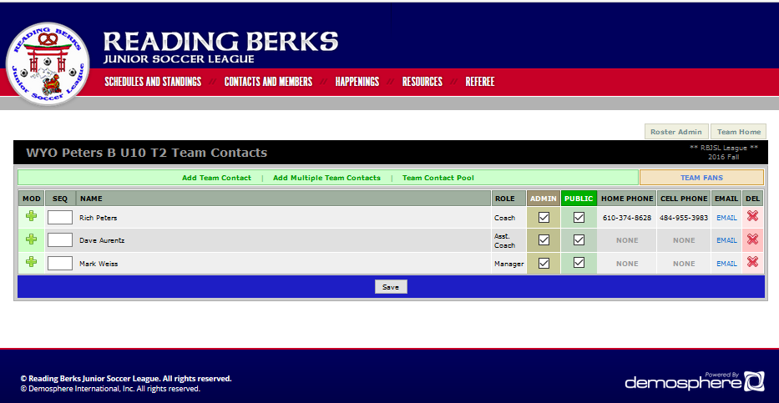

It will show who is the team coach and team manager.

Update the information and click SAVE at the bottom.

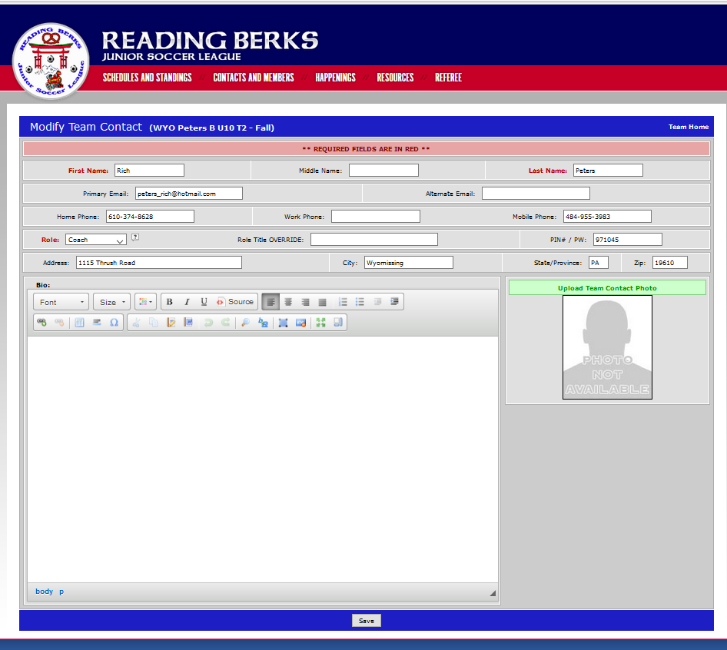

FIELDS

- Click on schedules as above.
- When the division page comes up, click on the correct division.
- The schedule for that division will come up.
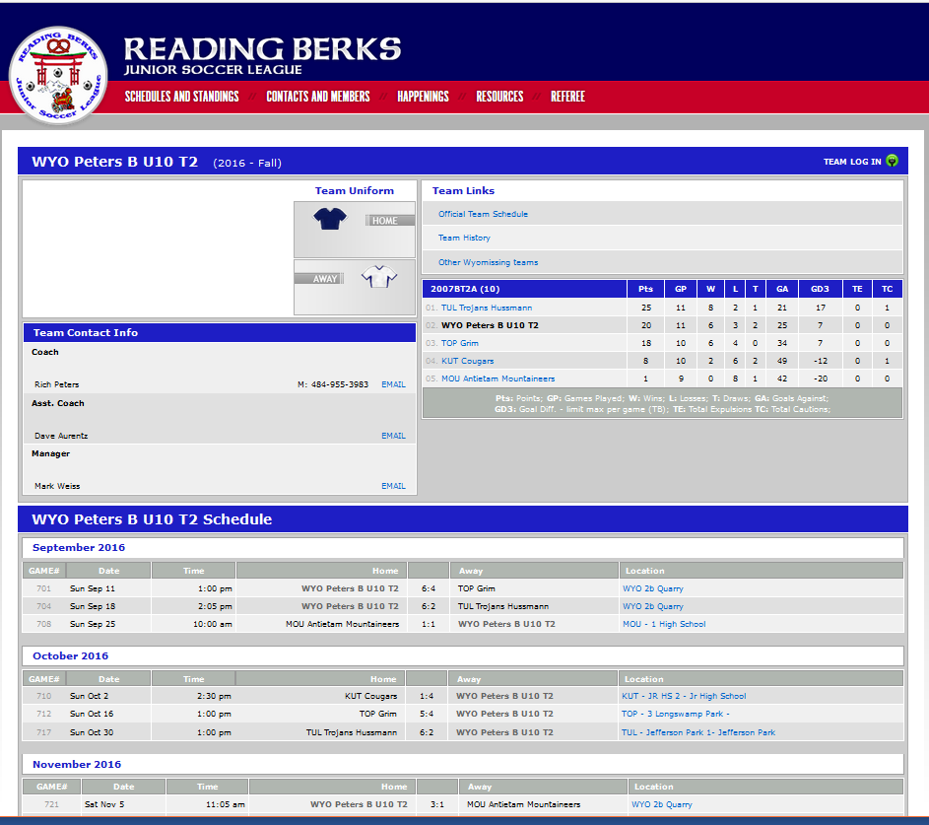

- It will bring up the field page. Select View Google Map to get directions to the field.
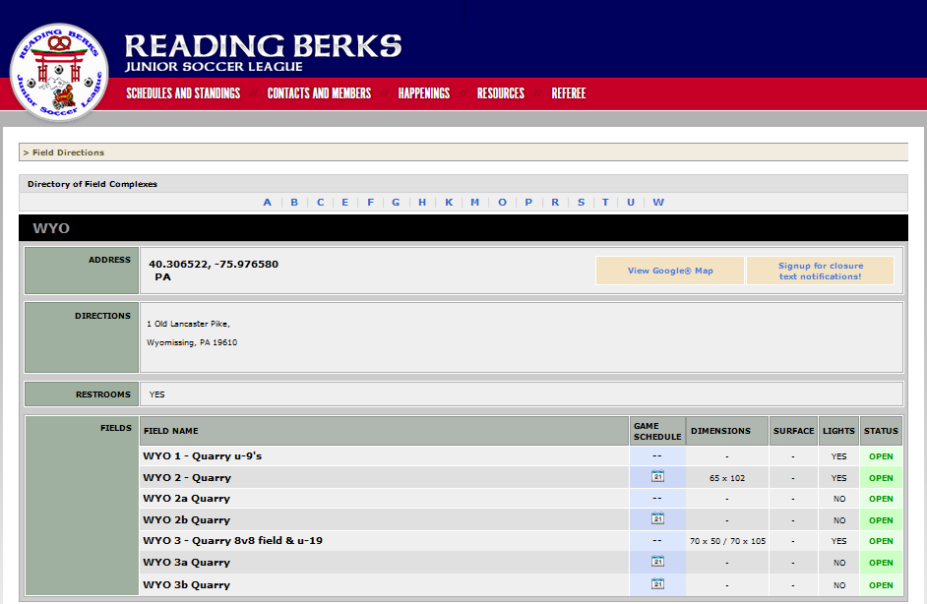

Enter the address from where you are coming from and get the directions.



